**Carlos Rebelo Exercise 3.1**

PatientController:

Index.html:

Patient Class:

PatientList Interface:

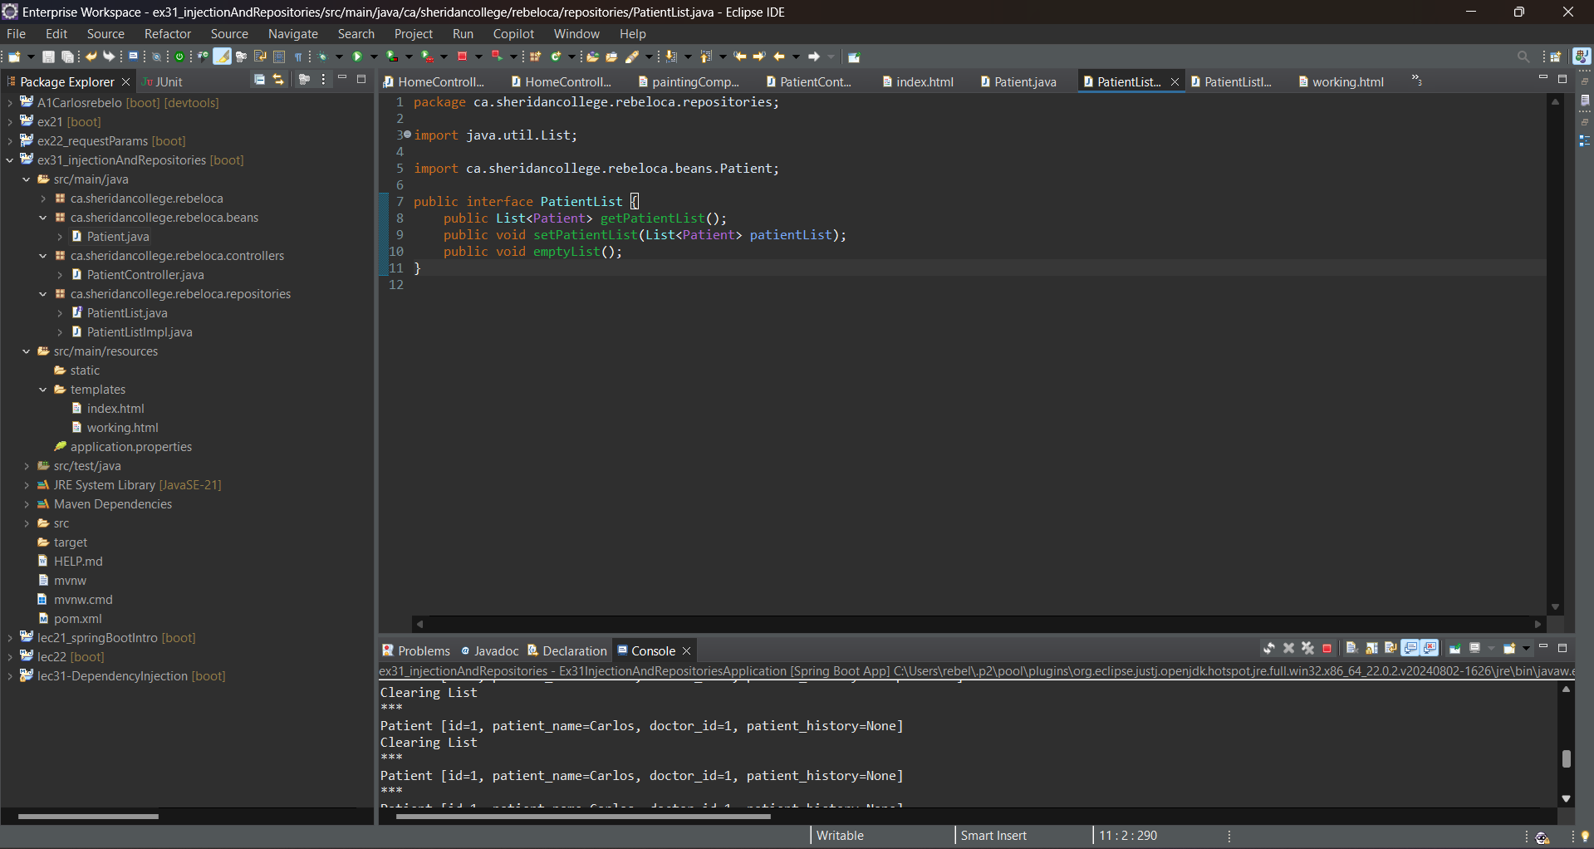

PatientListImpl Class:

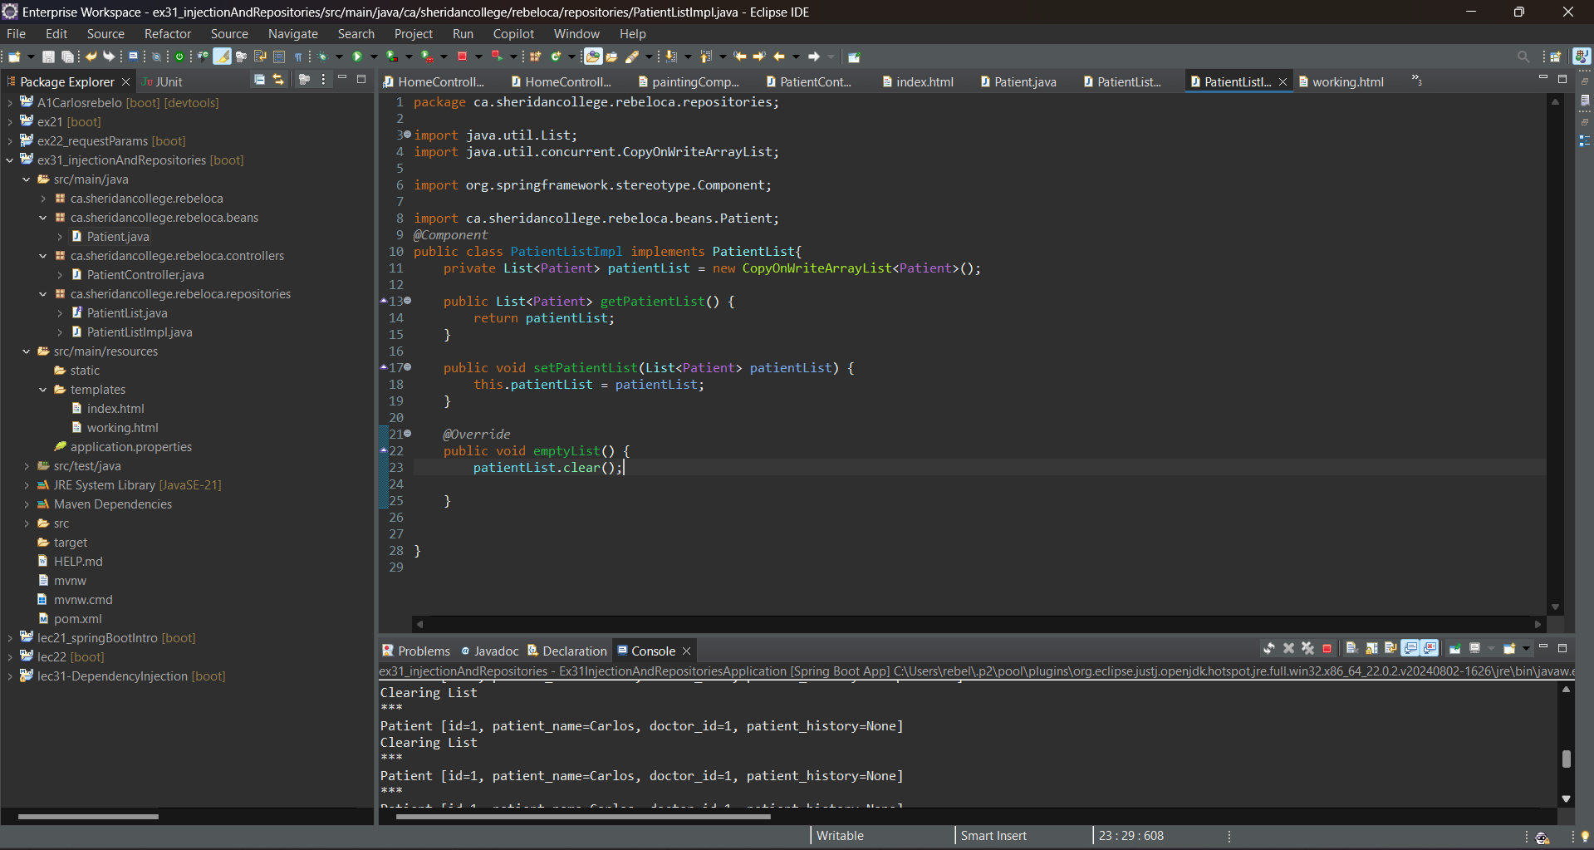

Working.html:

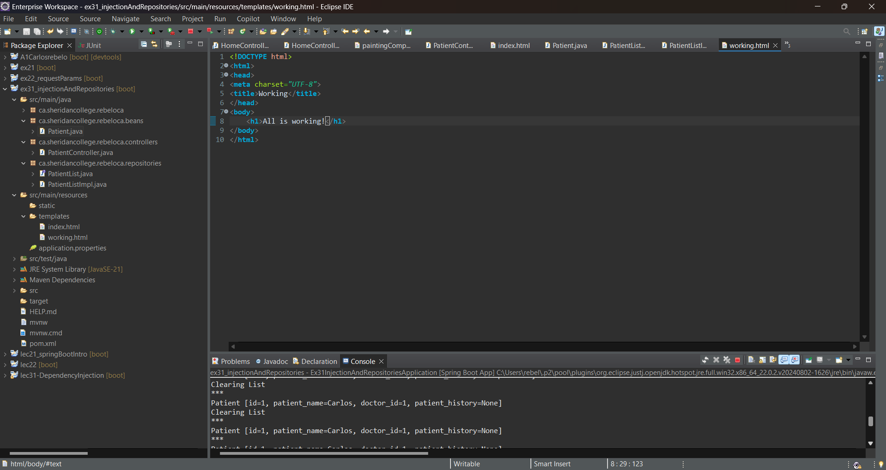

Index.html Output:

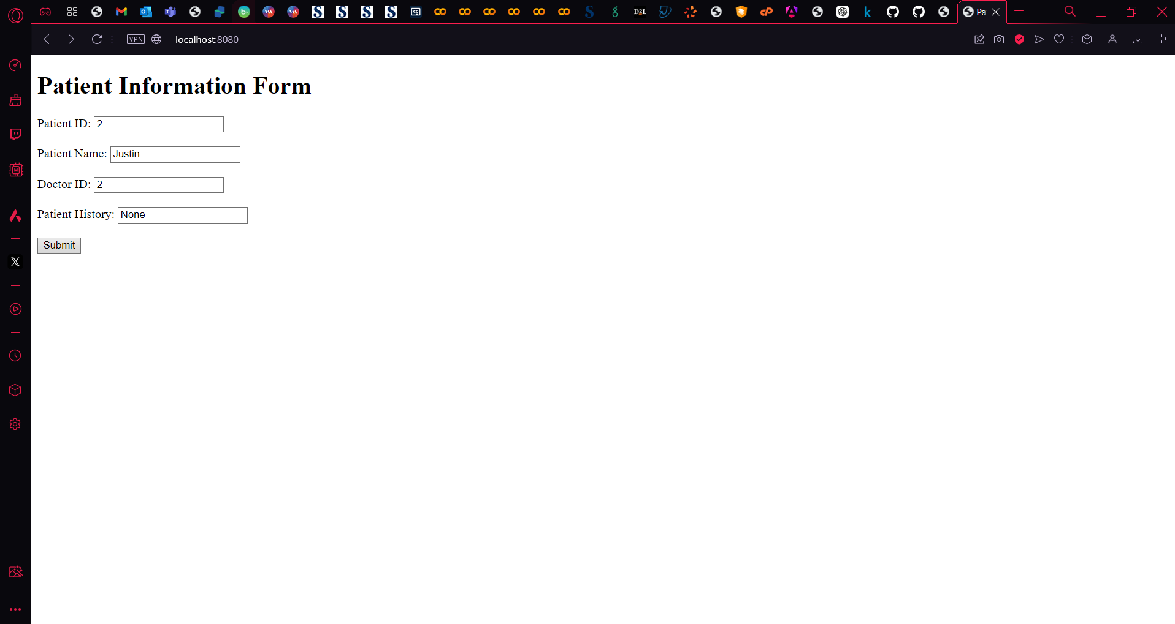

Working.html output:



Console output:

